Bryn Loftness

Hiking 112

Instructor Jim Heaps

**Rough Canyon (Micah Mine) – October 4th**

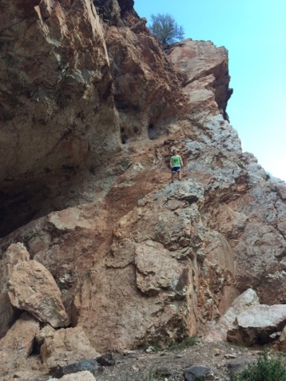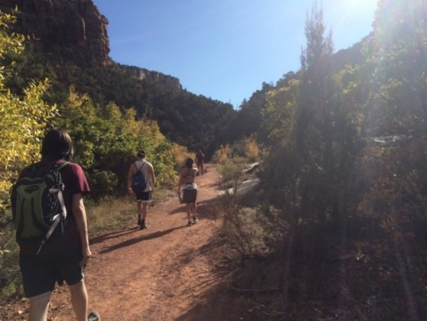I really enjoyed our hike this week. There were a lot of beautiful shiny rocks. My sister back in Minnesota used to collect rocks growing up so it was interesting to see some of the rocks that she used to collect on the ground in such a beautiful place; where they belong and originate. I know she would’ve really liked this trail. She is coming down for Thanksgiving so I am hoping it’s not going to be too cold so maybe we could hike it together.   
The views were really nice as well. I was able to get some really good shots of our group hiking with the blue skies as well as some adventuring in the rocks in the mine. (As you can see Justin doing →)

I really feel like I was in good shape for this hike. Even though I went into it feeling a bit tired and uninterested, as soon as I got walking I felt a million times better. I have been getting more and more in shape every week (even though this hiking class is my only structured exercise of the week). I have been walking a lot on my own as well as biking. I feel really great. I have actually been on a general fitness trend since New Year’s. My sister and I made a resolution to try and get healthier and we both have been doing really well. I’ve lost about 30 pounds which is a huge accomplishment.

Another group brought a dog along and were close in proximity to us for pretty much the whole time. I really miss my pups back home. I love spending time with dogs. He looked so happy to explore. I have two French Brittany’s back home. My dad is really into hunting and they have excellent sniffers! One is named Maiya and the other is Gabby. I am hoping to visit them over winter break. I am disappointed that next week is our last week. I wish there was another hiking class we could take that would expose us to even more trails. Coming from out of state I would love to see more of the area.